Grade | Course
Kindergarten/Kindergarten Readiness | Math: week of April 27-May 1
Unit Focus
Fluency within ten and for making ten is the focus of this week’s activities. K.OA.4; K.OA.A.5
**NOTE** On page 11-12 below, there is a calendar of fun/interesting math activities for each school day for the remainder of the year. Parents should keep this calendar as it will not be printed on future guides.
Day 1
15 minutes of I-Ready (Kindergarten only)
Daily Calendar Activity: April 27—bottom of packet (p.11)

Today’s Focus: Adding sums within ten: Today should focus on adding sums within 10. Later in the week we will focus on the sums of ten.

Task One: Picturing Addition (page 3)—this task lets students see the addition in multiple ways

Game Time! Addition Blocks: Click here (http://www.additionblocksgame.com/AdditionBlocksGame/) to play a game where you must find two numbers that create the falling number before it reaches the bottom. GOOD LUCK!

Complete 1-2 pages of your choice from the I-Ready at Home Packet

Day 2
15 minutes of I-Ready (Kindergarten only)
Daily Calendar Activity: April 28—bottom of packet (p.11)

Today’s focus: subtracting within ten by thinking addition and using the part/whole connection.

Task One: Think Addition to Subtract (page 4)—see directions below

Task Two: Adding and Subtracting within Ten (bottom page 5 below)- see directions below

Complete 1-2 pages of your choice from the I-Ready at Home Packet

Day 3
15 minutes of I-Ready (Kindergarten only)
Daily Calendar Activity: April 29—bottom of packet (p. 11)

Today’s focus: Numbers that combine to make ten…sometimes called ‘friends of ten’.

Task: Combinations of Ten: (page 6)-see directions below

Task Two: Make Ten on a Ten Frame (page 7)—making ten on a ten frame

Game Time! Alien Addition: Click here( https://bit.ly/2Xs3VLd ) to see if you can solve problems before the aliens attack! (Parents: be sure to set the range to 1-10)

Complete 1-2 pages of your choice from the I-Ready at Home Packet

Day 4
15 minutes of I-Ready (Kindergarten only)
Daily Calendar Activity: April 30—bottom of packet (p. 11)

Today’s focus is on partners of ten but when subtracting. Students should think about what partners with that number to make ten and conclude that it is the difference between that number and ten. This would also be good to walk on a number path!!

Task: Subtract from Ten (page 8 below)

Extension: Headbands! (bottom of page 8)

Complete 1-2 pages of your choice from the I-Ready at Home Packet

Day 5
15 minutes of i-Ready(Kindergarten only)
Daily Calendar Activity: May 1—bottom of packet (p. 11)

Today’s focus is to continue to practice fluency within ten and for ten.

Task one: Domino addition (page 9 below)

Task Two: Memory Game (page 10 below)—be sure to encourage discussion around the sums that do not make five or ten as well as those that do.

Game Time! Click here (https://bit.ly/2UXirsJ) to play Minus Mission to work on your subtraction within 20. Parents: Again, be sure to set the range of 1-10

Complete 1-2 pages of your choice from the I-Ready at Home Packet

Day One Task
Picturing addition
Use the template to model for the following addition problems. You may use beans or cereal as the manipulatives for the ten frame and number train. The picture and equation can be written on another sheet of paper.
4 + 3
2 + 6
5 + 4
3 + 3
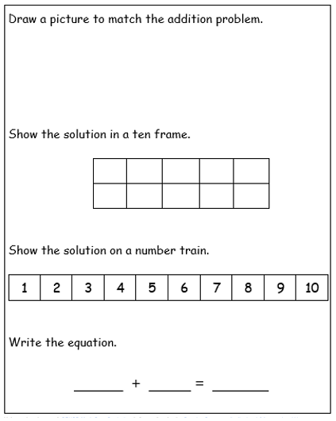

Day Two Task One:
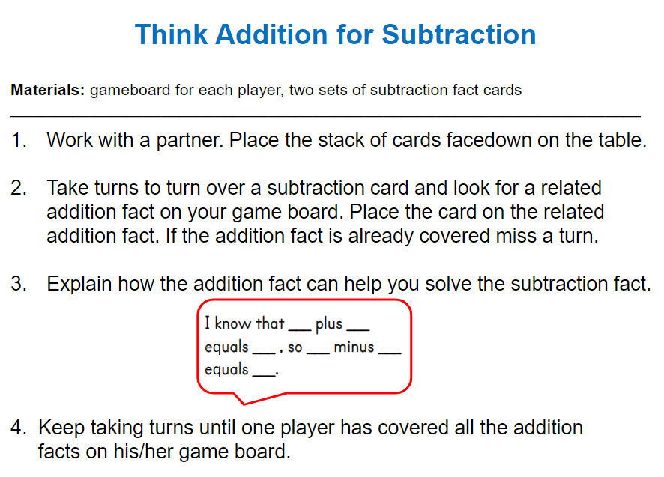
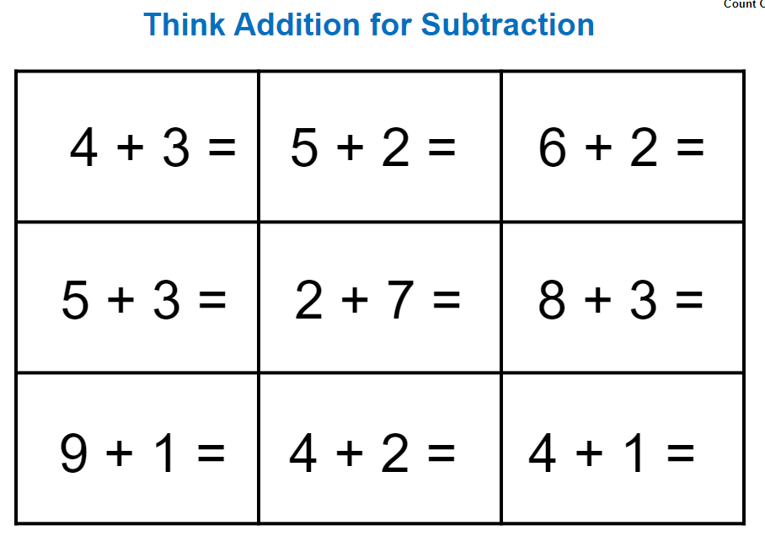

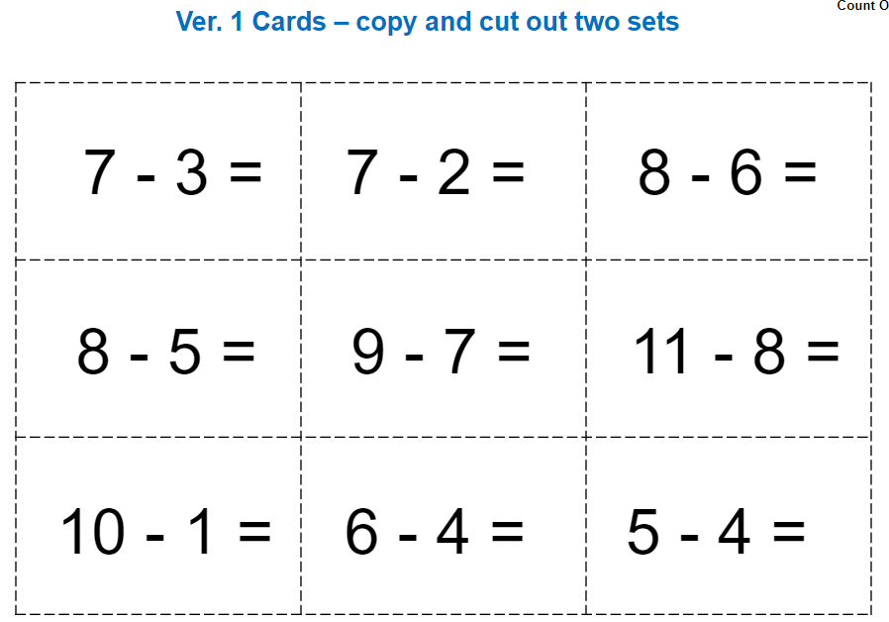
Day Two, Task Two:
Adding and Subtracting Within 10 (Source: Open Middle)
Using the digits 1 to 9 at most one time each, place a digit in each box to make a true statement. (can use digit cards 1-9 at the bottom on page 12)

Day Three Task: Combinations of 10

Use two different crayons to color in each train with different combinations of 10. On the line below each train, write an equation for that combination of 10. The first one has been done for you as an example.

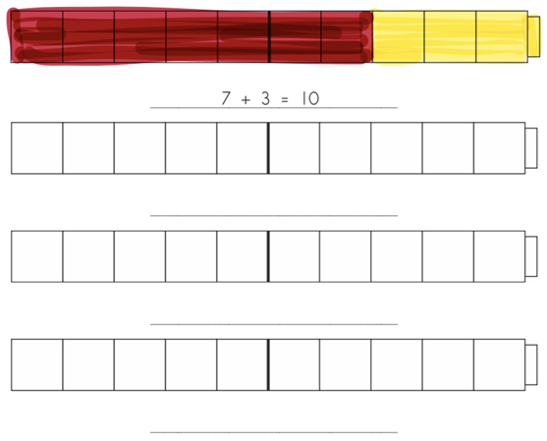
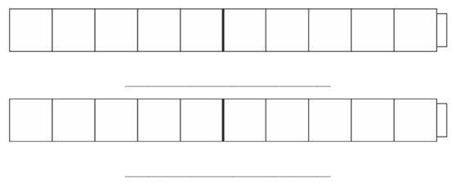

Task Two: Can use digit cards on page 12 below. Use cereal, beans, coins, toys, etc. as the “red/yellow counters”
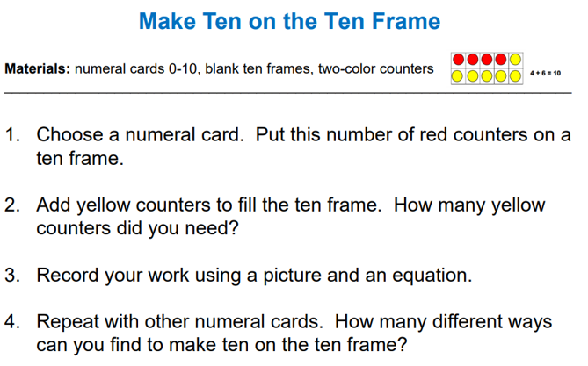

Day Four: Task One: Subtract from Ten
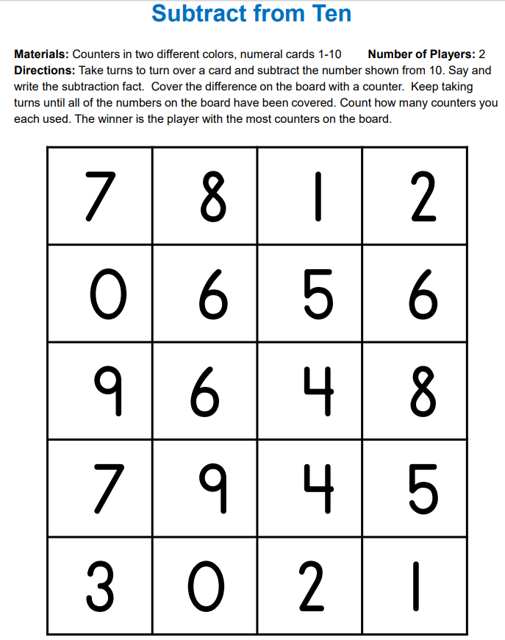

Extension: Headbands! Create a set of playing cards with only the digits 2-9 (several copies would be great!) Draw a card and place it on your forehead so the student can see. Have them tell you what the partner of ten would be. Then let them put the card on their forehead so only you can see it and tell them what the partner of ten would be and the student tells you what card is on their head
Day Five Task: Domino Friends of Ten
I picked 3 dominoes out of a bag and they all had exactly 10 pips, but the same number was not on both sides of any of the dominoes. Which dominoes could I have picked? Is there more than one answer? (use the blank dominoes below for students to draw the pips/dots for each possibility)
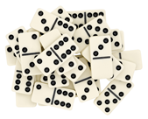
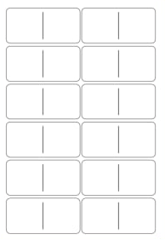

Memory Game
Materials: Playing cards
- Create a deck from 4 ones or aces, 4 twos, 4 three, and 4 fours.
❏ Deal out the cards face down.
❏ Players take turns turning two cards face up and state the sum of the two cards.
If a player turns a pair upward and that pair sums to 5, the player puts that pair of cards in their stash and plays again.
❏ If the upward pair does not sum to 5, the player turns the cards back face down, and the next player moves.
❏ The game ends when the cards are all claimed. Whoever has the most cards wins.
Extension: Like 5-Sum-Memory but the deck consists of 2 ones or aces, 2 twos, 2 threes, 2 fours, 2 fives, 2 sixes, 2 sevens, 2 eights, and 2 nines, and the target sum is 10 instead of 5.
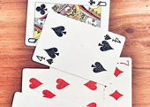

Kindergarten Math Calendar: April 27- May 22
April 27  Count the buttons on shirts or coats. Which one has the most buttons? | April 28  Count how many times you can hop on one foot. Count how many times you can bounce a ball. | April 29  Have someone tell you a number from 1-20. Count out that many of something (cereal, toothpicks, pennies…). | April 30  Use your number cards 1-20. Mix them up and put them back in order. | May 1  Practice counting on from numbers. Can you count on starting at 6 or 9 or 15?
May 4  Use your number cards 1-10. Pick a number and tell which number is 2 more. | May 5  Use your number cards 1-10. Flip over 2 number cards. Tell which number is greater. Count out cereal or toothpicks or cotton balls to prove it. | May 6  Take a walk outside to look for shapes. When you get back inside, draw a few shapes you saw. | May 7  Pick a toy. Find 3 things that are longer than that toy. Name something shorter than that toy. | May 8  Take a walk and count your steps.
May 11  Count the number of spoons in the kitchen drawer. Count the number of forks. | May 12  Guess how many cookies are in a package or how many grapes are in a bunch. Count to see. | May 13  Every person has 10 toes. If you counted the toes on 6 people, how many toes would there be? How many toes for 8 people? | May 14  Pick a number card. Tell how many is one more. Tell how many is one less. | May 15  Name 3 things that are shorter than you. Name 3 things that are taller than you.
May 18  Play a game of War, Old Maid, Uno, or Crazy Eights. | May 19  Use different coins or other small items to make a pattern (e.g., dime, dime, penny, dime, dime, penny). | May 20  Gather 5 different objects. Order them from shortest to longest. | May 21  Have everyone in your family write their first name. How many letters are in each name? Which name has the most letters? | May 22  Play “I Spy” for shapes. “I Spy a circle or triangle or cube or sphere…”

1 | 2 | 3 | 4 | 5
6 | 7 | 8 | 9 | 10
11 | 12 | 13 | 14 | 15
16 | 17 | 18 | 19 | 20

