Grade | Course
Kindergarten | Math week of May 11-15
Unit Focus
This week will focus on math challenges that promote problem solving and FUN!
Day 1
15 minutes of iReady (K only)
Complete the daily calendar activity for May 11 (calendars were printed on last week’s guides)

Today’s focus is on noticing same and different. Encourage students to discuss what they notice but to also use numbers when possible to describe the sameness or differences.

Task One and Two: see below p. 3
Task Three and Four: See below p. 4

https://mathbeforebed.com/2018/03/29/which-egg/
https://www.youtube.com/watch?v=msBlyCXxf8g (pre-lesson video)

Day 2
15 minutes of iReady (K only)
Complete the daily calendar activity for May 12 (calendars were printed on last week’s guides)

Today’s focus is on finger awareness using a finger maze then using those fingers to make partners of ten.

https://www.youtube.com/watch?v=73av5oijolU (Making 10)

Task One: Finger Mazes (see pgs. 5-8 below)
Task Two: Ten Fingers (top of page 9 below)

Day 3
15 minutes of iReady (K only)
Complete the daily calendar activity for May 13 (calendars were printed on last week’s guides)

Today’s focus is on Estimation.

Task one: Esti-mysteries (bottom of p. 9 below and clue cards p. 10)

https://www.youtube.com/watch?v=BQwiJQD9IYs (for parents)
https://www.youtube.com/watch?v=ygO4la2Ljug (pre-lesson video)

If you liked this activity, click here for powerpoints with more Esti-mysteries for you to solve!

Day 4
15 minutes of iReady (K only)
Complete the daily calendar activity for May 14 (calendars were printed on last week’s guides)

Today’s focus is on shapes positional words and seeing and using shapes in the world!

Task One: Positional Shapes (p. 11 below)
Task Two: The Shape of Things…..Click to Listen to the book The Shape of Things (p. 12 below)

https://www.youtube.com/watch?v=yrONWJiIzNw (for parents)
https://www.youtube.com/watch?v=YxoLlSTu1jo (review of shapes prior to lesson)

Day 5
15 minutes of iReady ( K only)
Complete the daily calendar activity for May 15 (calendars were printed on last week’s guides)

Today’s focus is on parts and wholes using SPLAT!

https://www.youtube.com/watch?v=GyK8iEO5-GI (number bonds)

Task One: SPLAT! (see cards on p. 12-13 below)
SPLATS to try by clicking here.

Day One:
Discuss the things that are the same and different between the two pictures in each task below.
Task One:
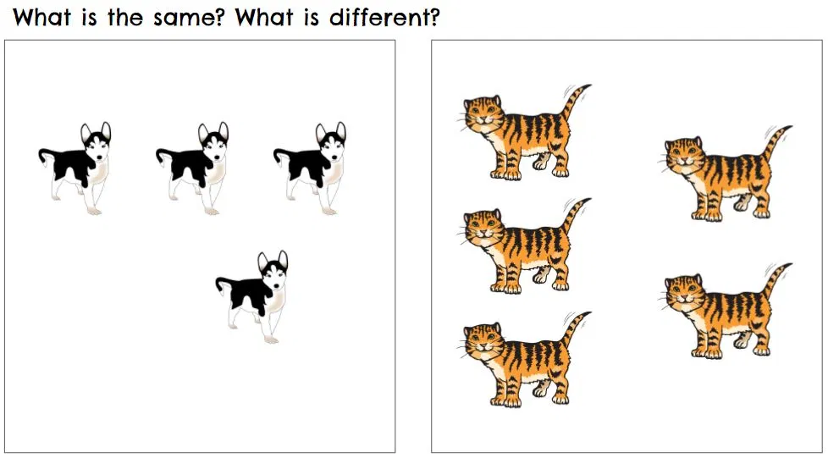

Task Two:
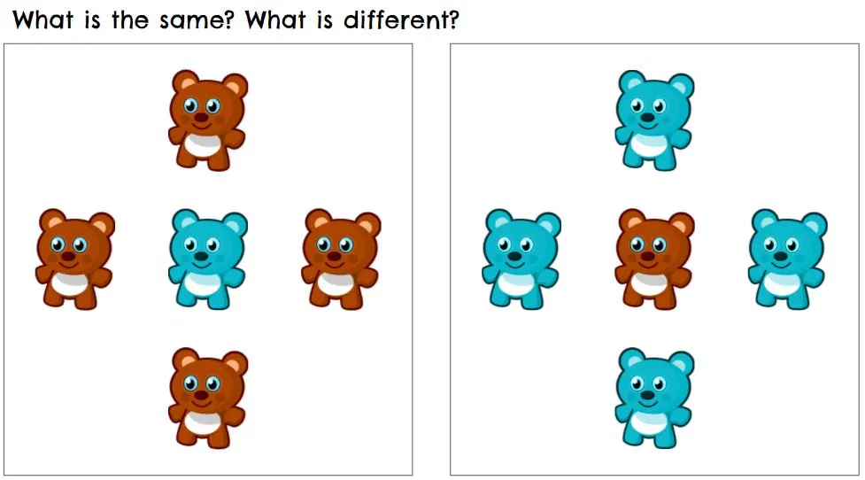

Task Three:
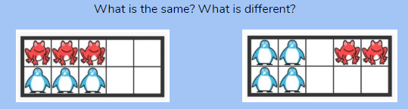
Task Four:
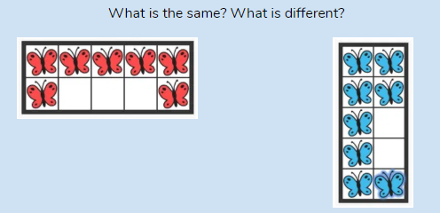

Day Two: Finger Awareness
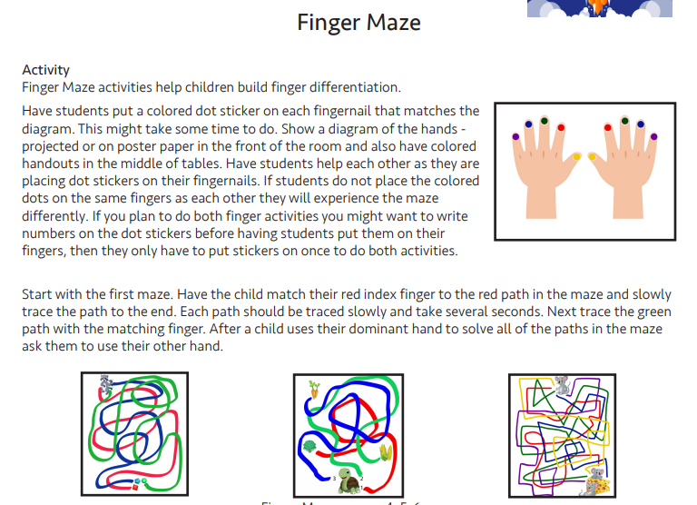

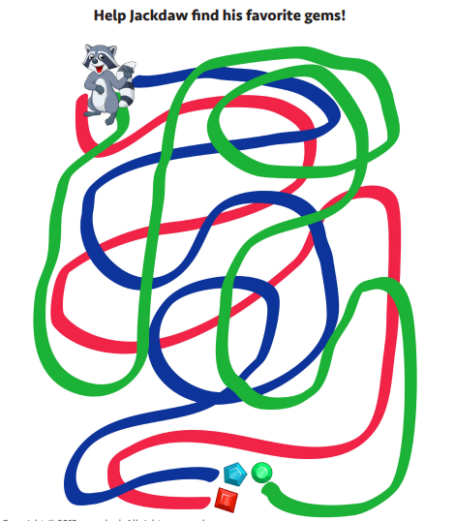
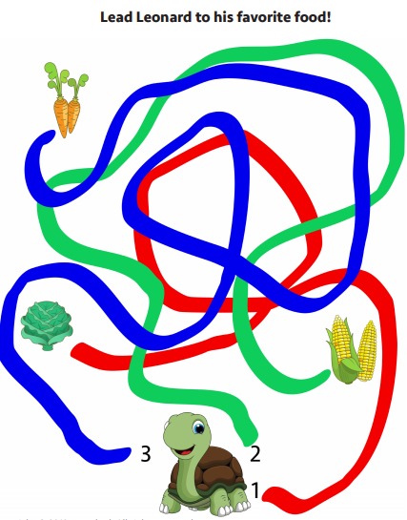
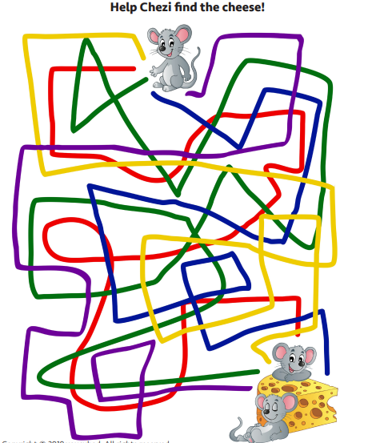

Day Two, Task Two:
Now that you’ve worked on finger awareness, let’s use your fingers to “Make It Ten”!
Materials: Just your hands!
This is a super-quick, cooperative game for two people. One person puts forward some number of fingers. The second person puts forward the number of fingers required to “Make It Ten.”
When there are ten fingers forward, the two players give each other a “high ten.”

Day Three: Esti-Mysteries

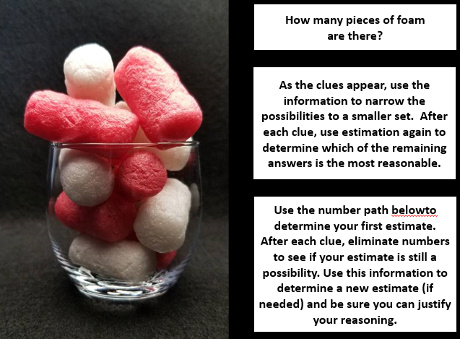

Cut the clue cards and let students turn them over one at a time or read the clues, one at time, to students and have them make adjustments to their original estimate.

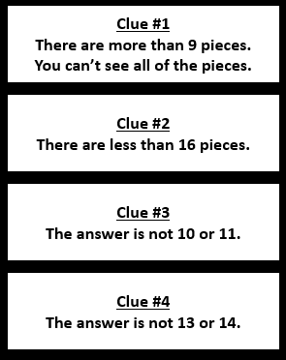

Use the number path below to eliminate choices as clues are red aloud.
8 | 9 | 10 | 11 | 12 | 13 | 14 | 15 | 16

Day Four: Shapes Task
Using the following picture, complete the following sentences (using the phrases: above, below, beside, in front of, behind, and next to)
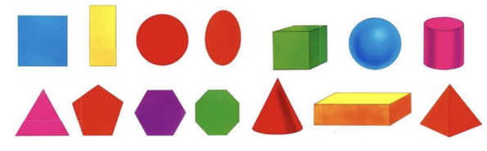

A. The cube is ___________ the sphere and ___________ the triangle.
B. The hexagon is __________ the pentagon and __________ the circle.
C. Use the shape names to complete the following statements:
D. The ________ is next to the ________ and above the __________.
E. The ________ is beside the __________, above the ___________, and below the ___________.
Task Two: The Shape of Things
Click to Listen to the book The Shape of Things

Day Five SPLAT!
Look at the SPLAT on the card below. What could be under the green and yellow splats? Remember the whole is 10 there will be different numbers of dots under each color SPLAT below. After you make your predictions, look at the next card that shows what is under one splat. Use that information to modify your guess.

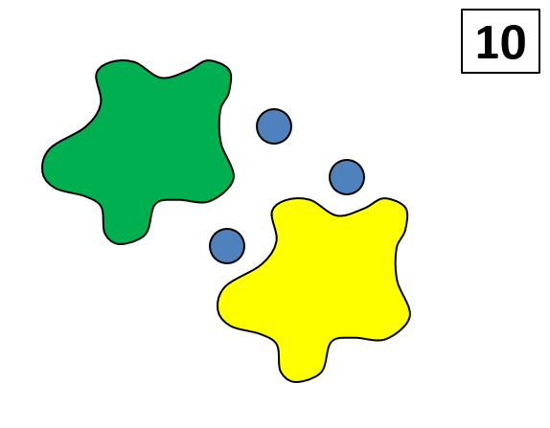

Card Two:
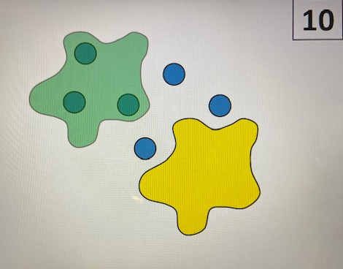

Answer Card:
