Grade | Course
Kindergarten/KR | Math week of May 4-May 8
Unit Focus
This week we will focus on the mathematical thinking and reasoning and justifying our thinking.
Day 1
15 minutes of iReady (K only)
Complete the calendar activity for May 4 (calendar was on last week’s guide)

Today’s focus is on mathematical reasoning and justification. The thing to remember about WODB (Which One Doesn’t Belong) pictures is that you can justify that EVERY picture doesn’t belong for some reason. The focus is on students explaining why the one they chose doesn’t belong and then challenging them to think of a reason why each of the others might not belong. If able, choose one you think doesn’t belong and challenge your student to see from your point of view.

Video: https://www.youtube.com/watch?v=msBlyCXxf8g

Task: Which One Doesn’t Belong? (see p. 3-4 below)

Complete 1-2 pages of your choice from the I-Ready at Home Packet

Day 2
15 minutes of iReady (K only)
Complete the calendar activity for May 5 (calendar was on last week’s guide)

Today’s focus is parts and wholes. Students will evaluate a visual SPLAT and determine what is under the “splat” when given the whole and one part. They will write an equation to match. Then they can complete task two, Birds on a Fence for the number 7.

Video: https://www.youtube.com/watch?v=XCm_NXSzhl0

Task One: SPLAT! (top of page 5)
Task Two: Birds on a Fence (bottom of page 5)

Complete 1-2 pages of your choice from the I-Ready at Home Packet

Day 3
15 minutes of iReady (K only)
Complete the calendar activity for May 6 (calendar was on last week’s guide)

Today’s focus is on the count sequence, writing numbers within 20 and using visuals for counting

Video: https://youtu.be/By2hmo323xM

Task One: Caterpillar Counting (see page 6-7 below)
Task two: Visuals for Counting (see page 7 below)

Complete 1-2 pages of your choice from the I-Ready at Home Packet

Day 4
15 minutes of iReady (K only)
Complete the calendar activity for May 7 (calendar was on last week’s guide)

Today’s focus is on patterns. Student will examine and create patterns in figures then examine patterns in teen numbers.

Video: https://youtu.be/lLPsPpmI9VA

TASK: Visual Patterns—(see p 8 below) –discussion about what was happening each time the pattern changed will be important.

Task Two: Patterns in Teen Numbers: (see p. 9 below) Students will work with ten-frames to create several teen numbers and then discuss the patterns they noticed.

Complete 1-2 pages of your choice from the I-Ready at Home Packet

Day 5
15 minutes of iReady (K only)
Complete the calendar activity for May 8 (calendar was on last week’s guide)

Today’s focus is on solving logic puzzles involving addition. These puzzles will be a bit of a challenge.

Task: Logic Puzzles (see p. 10-11 below)

Complete 1-2 pages of your choice from the I-Ready at Home Packet

Day One: Which One Doesn’t Belong
In each puzzle below, explain why each one “doesn’t belong” and be sure to explain your reasoning.

For example, in the pic to the right,
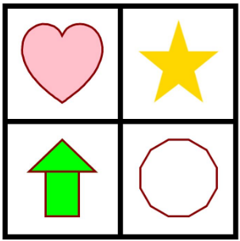
*the heart doesn’t belong because it’s the only one with curved sides.
*circle doesn’t belong because it’s the only one not filled in.
*the star doesn’t belong because it’s the only one without a red outline
*the green figures doesn’t belong because it is made of two different shapes.
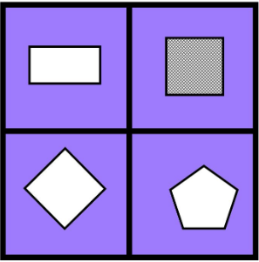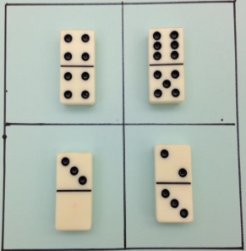

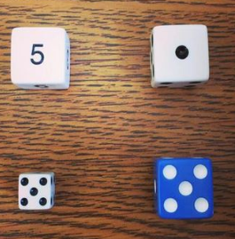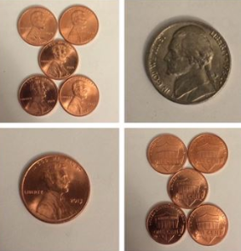

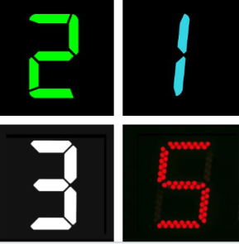

Day Two, Task One: SPLAT!
Look at the visuals below. The whole is in the box and dots represent one part. What part must be under the “splat”? Record you answers in an equation.
What’s under the SPLAT? How are these two splats the same and different? Could you make different splat for the number 6?
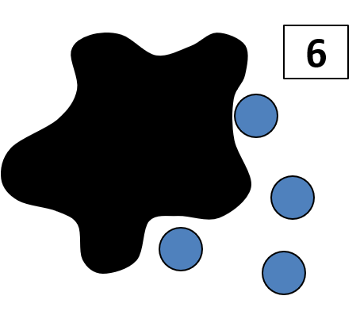
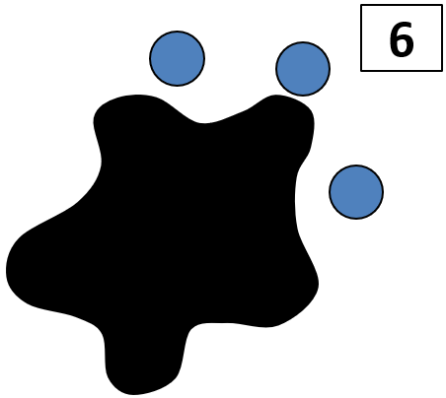

Day Two, Task Two: Birds on a Fence
Seven birds are on a fence. Some are blue and some are red. How many birds are red or blue. Write a number sentence and draw a picture to solve.
Is there another answer(s)? What would it be?
**use red and blue M&Ms, cereal, etc. to model the problem if needed**
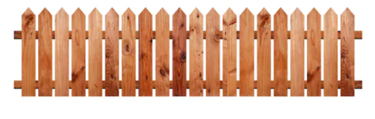
Day Three: Counting
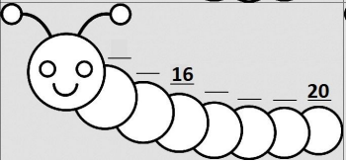
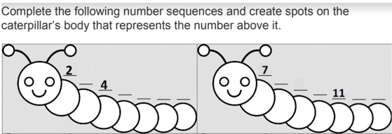

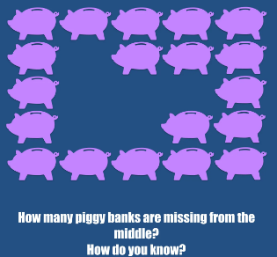
Visuals for Counting
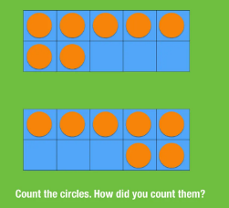

Day Four: Patterns
Below is a pattern of circles in stages 1-3 below. Draw what you think stage 4 might look like. Label how many circles are in each stage. What was happening to each new picture?

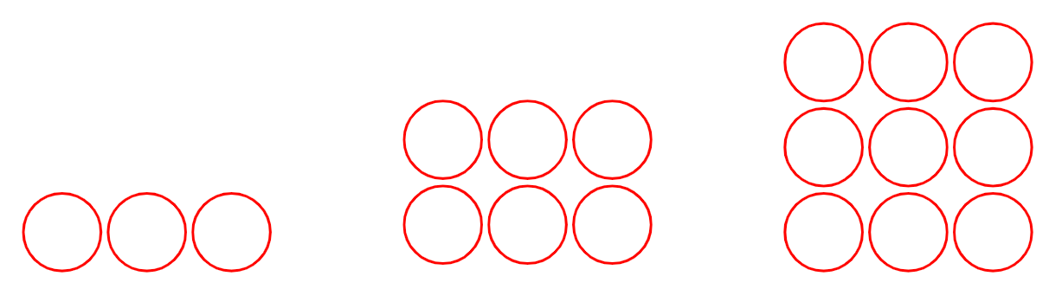

Below is a pattern of shapes in stages 1-3 below. Draw what you think stage 4 might look like. Label how many shapes are in each stage. What happened to each new figure?

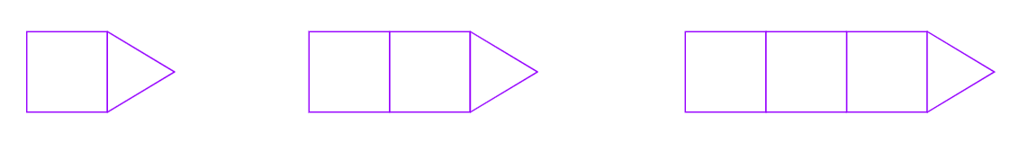

Look at the pattern below. What would the next figure look like? What is happening with each new figure?

Use items from around the house like cereal, M&Ms, coins, etc. to complete the task below.

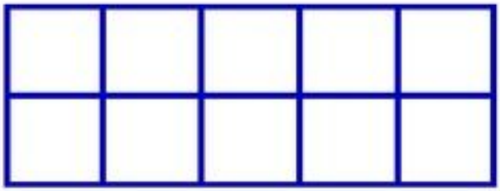
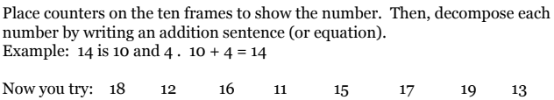
What pattern did you notice as you created all of these numbers on the ten frames?

Day Five: Logic Puzzles
What does each figure represent? What is the value of the last row?
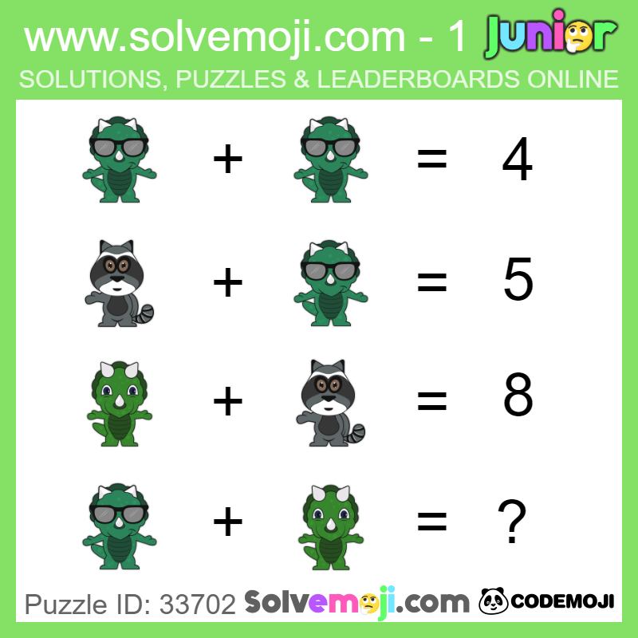
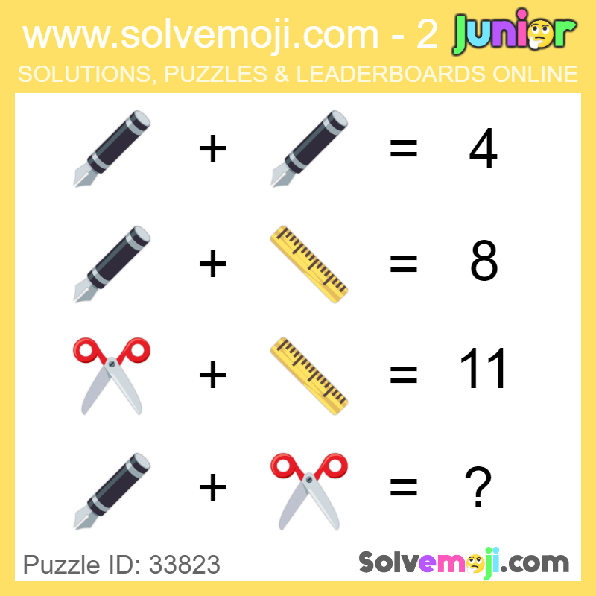

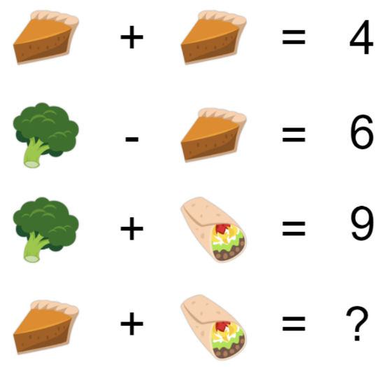
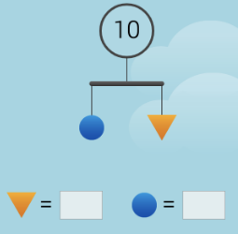

Extension: Can you create your own logic puzzle for someone else to solve?

