KR/Kindergarten | ELA-Week 6
Unit Focus
- Students will orally retell familiar stories, giving characters, setting and important events in the story.
- Students will write to retell those familiar stories, including all elements stated above.
- Students will orally identify main topic and retell key details of an informational text.
- Students will write to retell key details in informational text.
- Students will decode CVC words and/or use CVC words in above writings.
- Students will read decodable texts.
- Students will read sentences for fluency.
- Practice reading and spelling of sight words
Day 1
The Three Little Pigs from CKLA Open Source
15 minutes iReady Reading
- Parents read the passage. Have student read along or independently read, depending on ability.
- Have student give an oral and written response to the text.
- Have students create a flip book retelling events from the story by drawing and or writing what happened at the beginning, middle, and end of text.
- Writing Activity: Using illustration and writing, retell the story including characters, setting, and the events of the story. Try to use sight words, correct capitalization, finger space, and correct punctuation.
- CVC Word Practice: Build cvc words using magnetic letters on an aluminum pan or tray.
- https://www.youtube.com/watch?v=oDVAhDyHZaA&t=74s
- Sight Word Practice: Sight Word Go Fish. Make an extra set of sight word cards and use it to play a game of Go Fish!
- https://www.youtube.com/watch?v=0h1Q7SVKG0A
Day 2
Woodlands from CKLA Open Source
15 minutes iReady Reading
- Parents read the passage. Have student read along or independently read, depending on ability.
- Have students answer questions in response to the text. The questions are found at the end of the story.
- Have students illustrate 3 animals from the story and their habitats.
- Writing Activity: Choose an animal from the story. Write/illustrate information about the animal. Try to use sight words, correct capitalization, finger space, and correct punctuation.
- CVC Word Practice: Have students make cvc words by rolling alphabet cubes.
- Sight Word Practice: Flashlight Words. Tape sight words onto the wall or ceiling and turn the lights off. Use the flashlight to read the words.
- https://www.youtube.com/watch?v=x-ZDgAVQEqo
Day 3
Hoodoos Made of Rock from ReadWorks
15 minutes iReady Reading
- Parents read the passage. Have student read along or independently read, depending on ability.
- Have students answer questions in response to the text. The questions are found at the end of the story.
- Have students draw a picture of the main idea and key details from the text.
- Writing Activity: Using the information from the story, write/illustrate information about the hoodoos. Try to use sight words, correct capitalization, finger space, and correct punctuation.
- CVC Word Practice: Have students practice writing cvc words using white boards and dry erase markers.
- Sight Word Practice: Rainbow Sight Words. Write your sight words in different colors!
- https://www.youtube.com/watch?v=0TNX9MzAxzI
Day 4
Lily Makes Lemonade from ReadWorks
15 minutes iReady Reading
- Parents read the passage. Have student read along or independently read, depending on ability.
- Have students answer the guiding questions in response to the text. The questions are found at the end of the story.
- Have students create a recipe book and list and illustrate ingredients to make lemonade.
- Writing Activity: Write/illustrate about making lemonade. Try to use transition words like first, then, next and last. Try to use sight words, correct capitalization, finger space, and correct punctuation.
- CVC Word Practice: Word magic. Parent will say a cvc word ( ex. Cat) parent will then “perform magic” by changing the beginning or ending letter. “I said cat but my magic has now changed the C to an H... what word did my magic make?” The child should answer “Hat”. Practice cvc words with each vowel in the middle.
- Sight Word Practice: Sight Word SWAT! Place sight words on the floor. Have someone call out a sight word and then find it by hitting the word with a fly swatter!
- https://www.youtube.com/watch?v=os5qGD0kw58
Day 5
Clouds and Rain from ReadWorks
15 minutes iReady Reading
- Parents read the passage. Have student read along or independently read, depending on ability.
- Have students answer the guiding questions in response to the text. The questions are found at the end of the story.
- Have students draw and label different shapes of clouds they have seen in the sky.
- Writing Activity: Go outside and look at the clouds (if raining, think of a day you have watched the clouds). Write/illustrate about the different shapes/things the clouds look like. Try to use sight words, correct capitalization, finger space, and correct punctuation.
- CVC Word Practice: https://www.education.com/game/blending-sounds-spelling/
- Sight Word Practice: Build sight words using playdough or clay. If you don’t have either, then write sight words in shaving cream, whipped cream, chalk, sand, etc
- https://www.youtube.com/watch?v=6x60M4rbf8Q

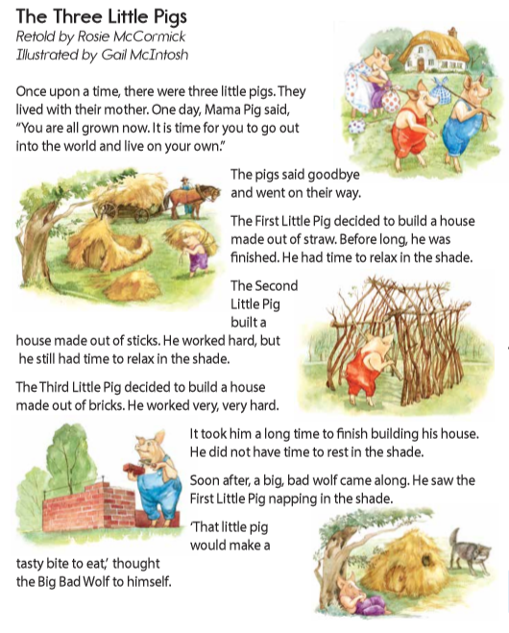
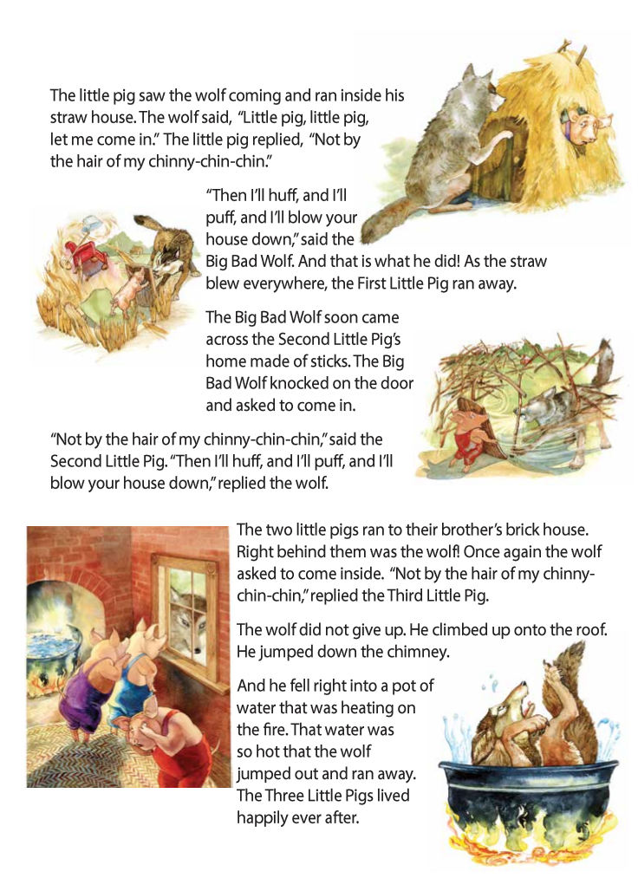
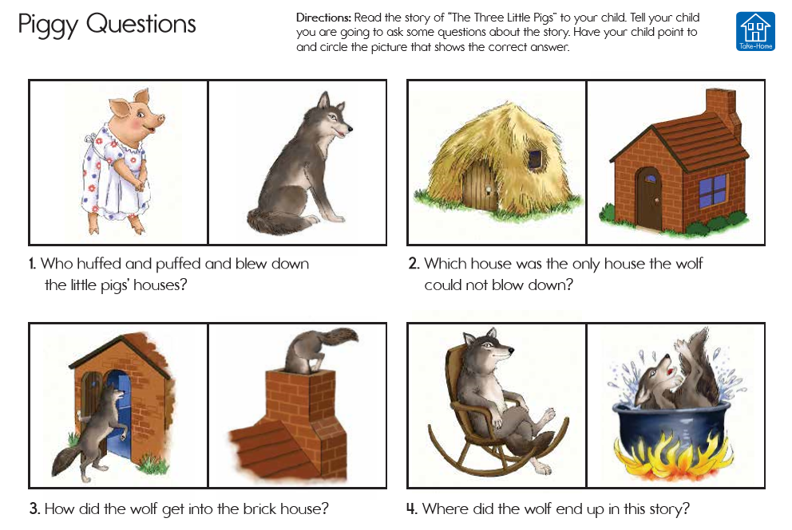

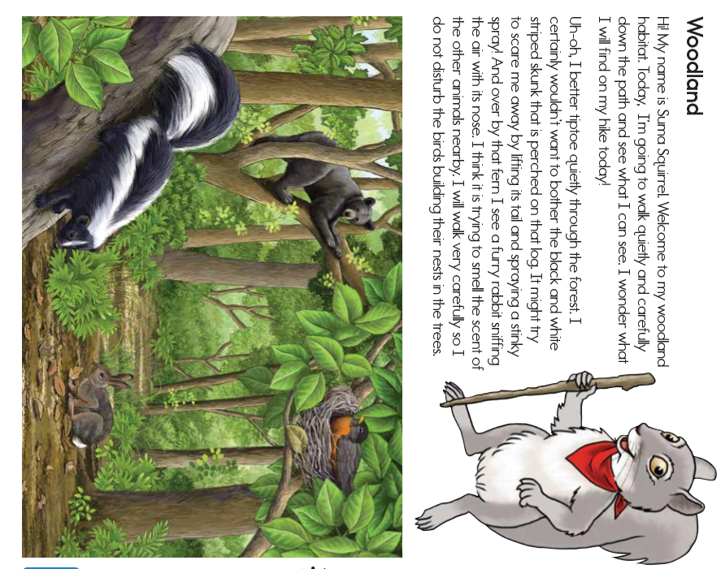

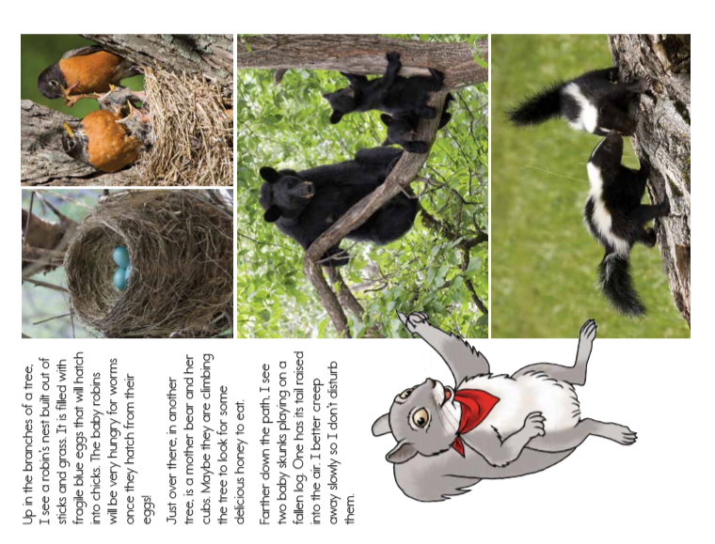

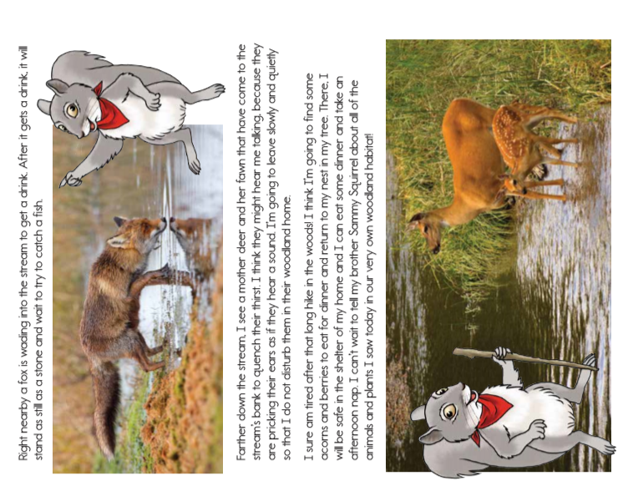
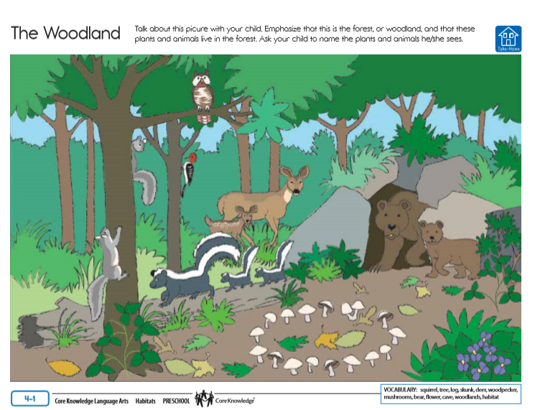
Day 3: Hoodoos Made of Rock
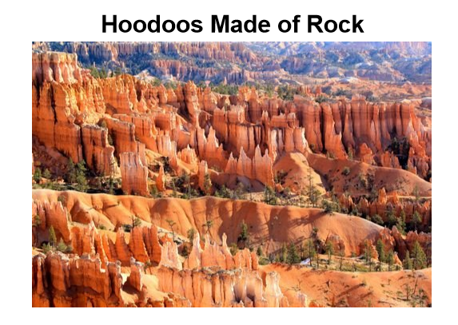
Have you heard of a hoodoo? A hoodoo is a special shape made of rock. It is a tall column!
There is a place in Utah that is filled with these special rocks. It is called Bryce Canyon. It has more hoodoos than any other place in the world! The rocky hoodoos there are colorful. They are pink, orange, and red.
These hoodoos formed over a long time. Water and ice shaped the rocky land into columns. The columns are different heights. Some are the size of a person. Some are more than 100 feet tall!

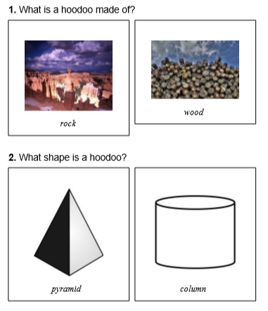

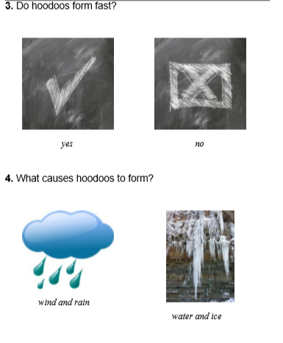

5. What color are the hoodoos in Bryce Canyon?
The hoodoos in Bryce Canyon are __________.
6. What did you learn from "Hoodoos Made of Rock"?
7. Draw a hoodoo

Day 4: Lily Makes Lemonade

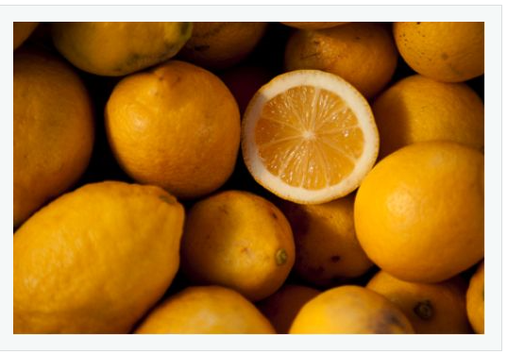
Lily’s friends are visiting her today. Olivia bakes oatmeal cookies. Sharon brings chips and dip.
Lily makes lemonade. She squeezes four lemons into a pitcher. Next, she adds four cups of water. Finally, she mixes one teaspoon of sugar into the pitcher. Lily tastes it.
“This lemonade is too sour,” she says.
She adds more sugar. She tastes it again. Now it is much better!

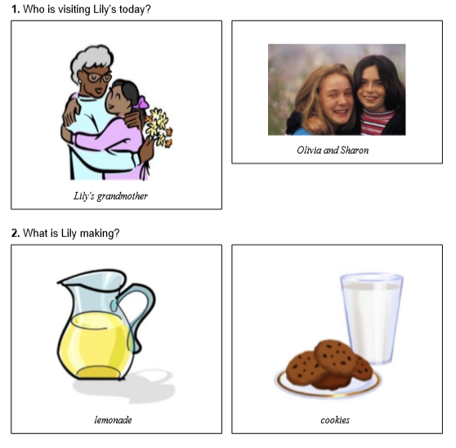
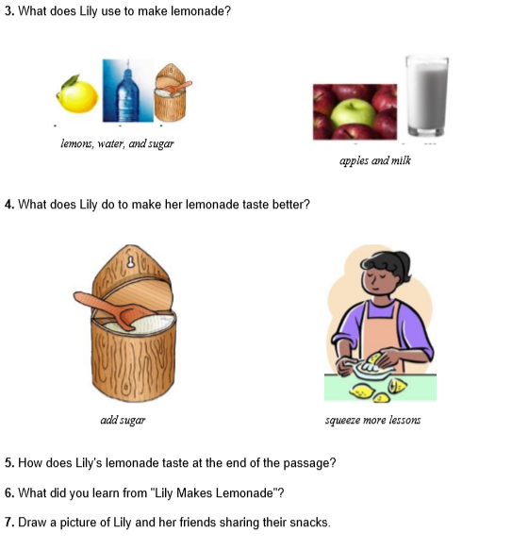

Day 5: Clouds and Rain
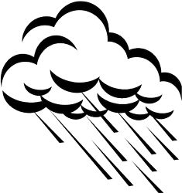
Look up at the sky. You may see clouds. What are clouds made of?
Clouds are made of tiny drops of water. Some clouds look white and fluffy. Some clouds look stringy, like wisps of hair. Other clouds look gray.
Gray clouds can bring rain. They are made of bigger drops of water. If the drops get too big, they fall from the sky. Now it is raining.
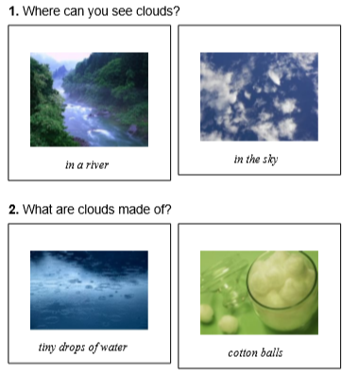

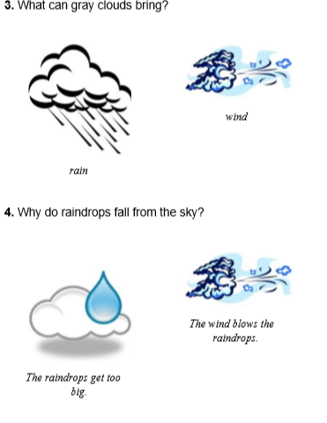
5. What can clouds look like?
Clouds can look like
6. What did you learn from "Clouds and Rain"?
7. Draw a picture of clouds in the sky.

