KR/Kindergarten | ELA-Week 5
Unit Focus
- Students will orally retell familiar stories, giving characters, setting and important events in the story.
- Students will write to retell those familiar stories, including all elements stated above.
- Students will orally identify main topic and retell key details of an informational text.
- Students will write to retell key details in informational text.
- Students will decode CVC words and/or use CVC words in above writings.
- Students will read decodable texts.
- Students will read sentences for fluency.
- Practice reading and spelling of sight words
Day 1
Why Flies Buzz from CKLA Open Source
*15 minutes of iReady reading
- Parents read the passage. Have student read along or independently read, depending on ability.
- Have student give an oral and written response to the text.
- Have student retell events from beginning, middle, and end of text.
- Complete a story map by having the student draw a picture including the characters, setting and problem/solution.
- Writing Activity: Write/illustrate about the animal that you thought caused all the problems and the story and why. Try to use sight words, correct capitalization, finger space, and correct punctuation.
- CVC Word Practice: Build cvc words using magnetic letters on an aluminum pan or tray.
- https://www.youtube.com/watch?v=oDVAhDyHZaA&t=74s
- Sight Word Practice: Pick 8 sight words and rainbow write them. Pick three colors and write the words once in each color.
Day 2
The Hare and the Tortoise from CKLA Open Source
*15 minutes of iReady reading
- Parents read the passage. Have student read along or independently read, depending on ability.
- Have students answer questions in response to the text. The questions are found at the end of the story.
- Have students retell the story by acting out the story just read using props from around the house or help your parents create puppets with construction paper, popsicle sticks or paper bags.
- Writing Activity: Write/illustrate the reason you think the tortoise won the race. Try to use sight words, correct capitalization, finger space, and correct punctuation.
- CVC Word Practice: Search for cvc words around your house and write them on a sheet of paper.
- https://www.youtube.com/watch?v=ii18uH36ySU
- Sight Word Practice: Sight word Bingo (select primer words or higher, based on your child’s reading level) https://www.abcya.com/games/dolch_sight_word_bingo
Day 3
Bright as the Sun from ReadWorks
*15 minutes of iReady reading
- Parents read the passage. Have student read along or independently read, depending on ability.
- Have students answer questions in response to the text. The questions are found at the end of the story.
- Have students draw a picture of the main idea and key details from the text.
- Writing Activity: Pretend you are a sunflower. Write illustrate about what you need to grow and/or what you would see as a sunflower. Try to use sight words, correct capitalization, finger space, and correct punctuation.
- CVC Word Practice: The parent will say a cvc word. The student will sound spell the word.
- https://www.youtube.com/watch?v=ZAZ74S0vPqs&t=72s
- Sight Word Practice: Sight Word Scavenger Hunt: Pick 10 or more words and write on notecards and hide around the house. Create a list for your child and help them hunt for the hidden words. When your child locates a word, have them read the word and use it in a sentence.
Day 4
How Plants get Water and Food from ReadWorks
*15 minutes of iReady reading
- Parents read the passage. Have student read along or independently read, depending on ability.
- Have students answer the guiding questions in response to the text. The questions are found at the end of the story.
- Have students draw a plant and label the parts of the plant.
- Writing Activity: After reading the story, write/illustrate about a plant’s roots. Explain why they are important and what they do for the plant. Try to use sight words, correct capitalization, finger space, and correct punctuation.
- CVC Word Practice: Word magic. Parent will say a cvc word ( ex. Cat) parent will then “perform magic” by changing the beginning or ending letter. “I said cat but my magic has now changed the C to an H... what word did my magic make?” The child should answer “Hat”. Practice cvc words with each vowel in the middle.
- Sight Word Practice: Sight Word Smash( select Kindergarten or higher based on your child’s individual level) https://www.roomrecess.com/mobile/SightWordSmash/play.html
Day 5
A Frog’s Life Cycle from ReadWorks
*15 minutes of iReady reading
- Parents read the passage. Have student read along or independently read, depending on ability.
- Have students answer the guiding questions in response to the text. The questions are found at the end of the story.
- Have students orally retell and draw a picture of the life cycle of a frog.
- Writing Activity: After reading the story, write/illustrate about the lifecycle of a frog. Try to use sight words, correct capitalization, finger space, and correct punctuation.
- CVC Word Practice: https://www.education.com/game/blending-sounds-spelling/
- Sight Word Practice: Sensory Sight words. Using something around the house (chalk, play doh, paint, salt or sugar on a plate) choose 10 sight words your child needs to practice and have them say the word, name each letter as they write it, and then say the word again.

Day 1: Why Flies Buzz from CKLA Open Source

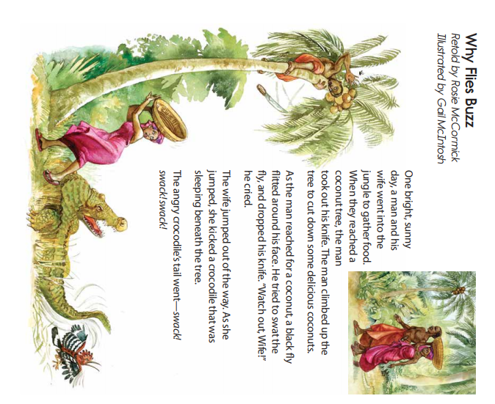

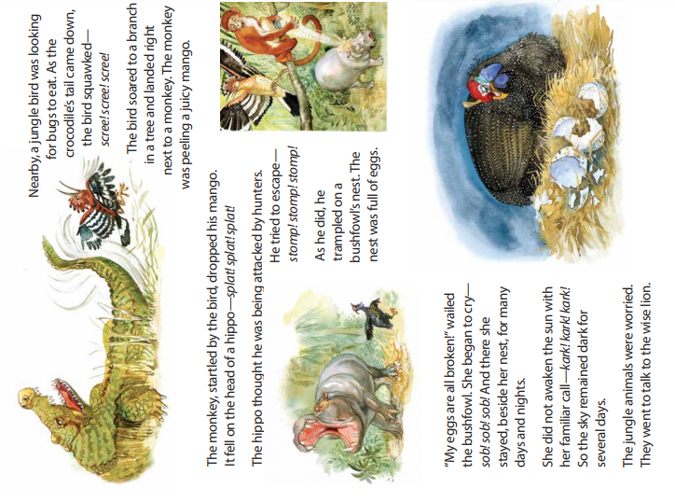

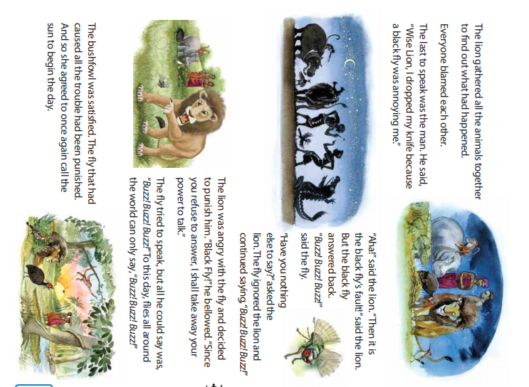
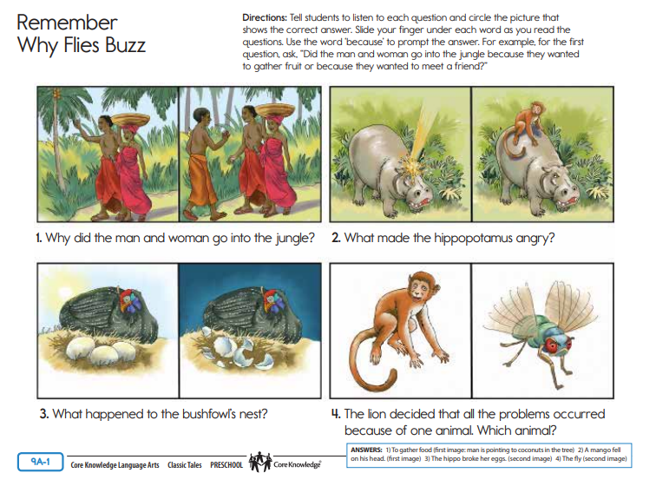

Day 2: The Hare and the Tortoise from CKLA Open Source
There once was a hare who was always boasting about how fast he was. He never got tired of telling the other animals how fast he was—and how slow they were. The hare was especially boastful when talking to the tortoise. “What a slow fellow you are!” he said to the tortoise one day. “I really feel sorry for you, having to creep along like that. Creep, creep, creep! It must take you all afternoon just to cross the field!” The tortoise was not amused. “You may be fast,” said the tortoise. “But I’ll bet I could beat you in a race.” “Ha, ha, ha!” the hare laughed. “That’s hilarious! You must be joking. A race between you and me wouldn’t even be close!” The tortoise replied, “Well then, let’s try. Suppose we race to the foot of the mountain.” “Sure thing!” said the hare. The other animals gathered around to watch the race. “Ready!” said the squirrel. “Set!” said the mouse. “Go!” said the raccoon. The hare darted off quickly and ran so far ahead that he was almost out of sight. The tortoise set off too, moving slowly but steadily. After he had gone about halfway to the mountainside, the hare looked back. He saw that the tortoise was far behind; so far behind it seemed as if he could never catch up.
“This is not much of race,” sniffed the hare. Since it seemed to him that the race was already won, the hare decided to stop and take a little break. He nibbled some carrots and some lettuce. He chatted with some friends. All this while, the tortoise kept moving—slowly but steadily. The hare looked back again and saw that he was still way out ahead, so he lay down in a pumpkin patch, closed his eyes, and pretended he was sleeping. He didn’t really mean to go to sleep. He just wanted to show the tortoise that he could take a little nap and still win the race. But it was a warm day, and it wasn’t long before the hare began to feel sleepy. Eventually he nodded off and began to snore. While the hare was napping, the tortoise kept moving—slowly but steadily. After fifteen minutes he crawled past the sleeping hare. After another fifteen minutes he was within a few feet of the finish line. That was when the hare woke up from his nap. He realized what had happened and set off running for the mountain as fast as he could. But it was too late. The hare arrived just in time to see the tortoise crossing the finish line before him.
So, the moral of the story is: “Slow and steady wins the race.”

Pictures for text:
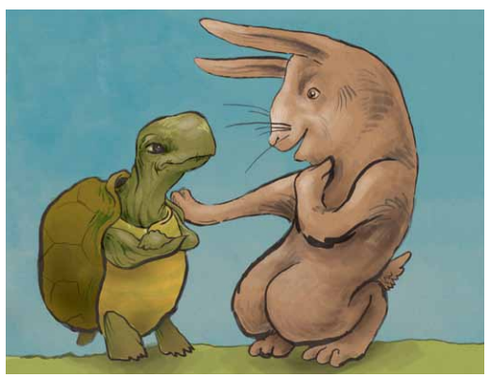
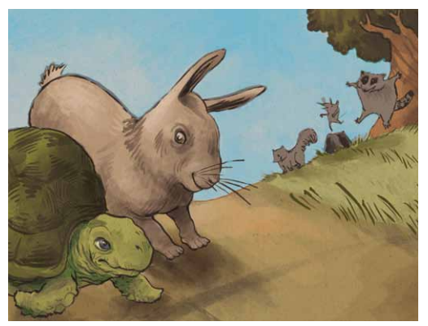
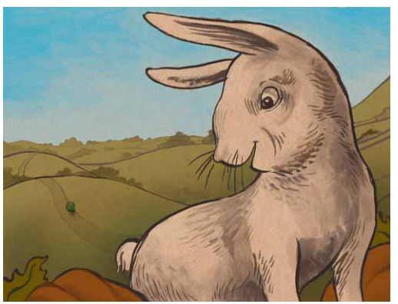

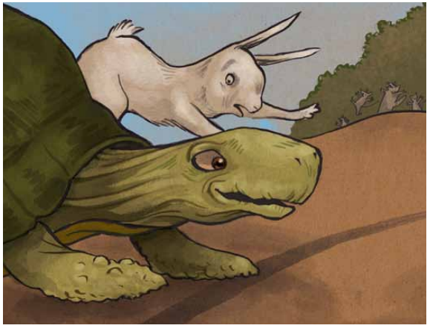
Questions:
- In this story, are the characters people or animals? What kind of animals are they?
- Why do the hare and the tortoise decide to have a race?
- Does the tortoise really think he can beat the hare?
- Who wins the race?
- How is the tortoise able to beat the faster animal, the hare?
- What is the lesson of this fable?
- Who is slow and steady in this fable?
- What do you think it means to say “slow and steady wins the race”?

Day 3: Bright As the Sun from ReadWorks
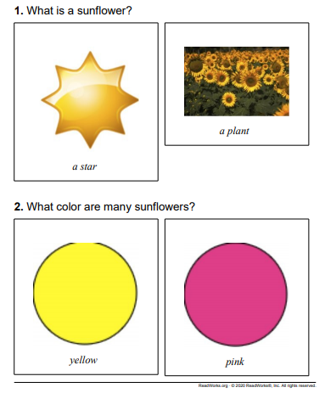
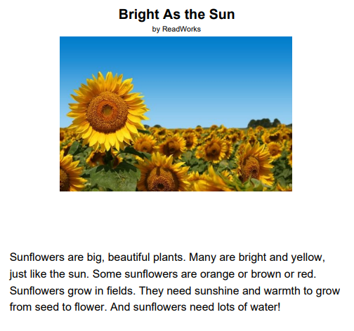

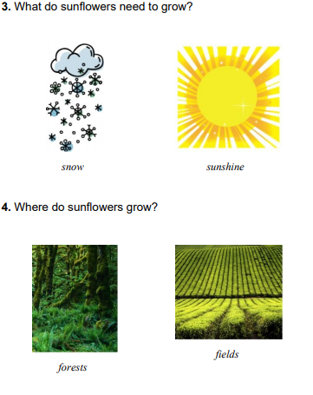

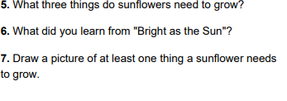

Day 4: How Plants get Water and Food from ReadWorks
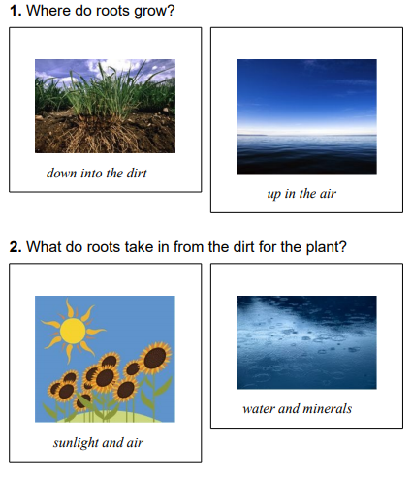
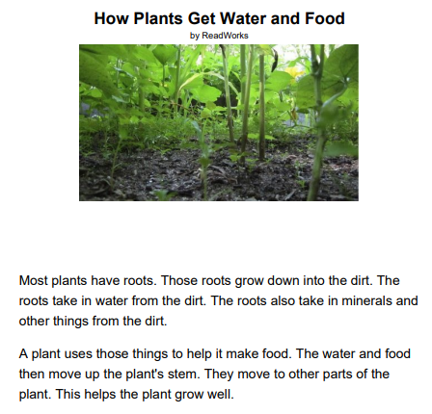

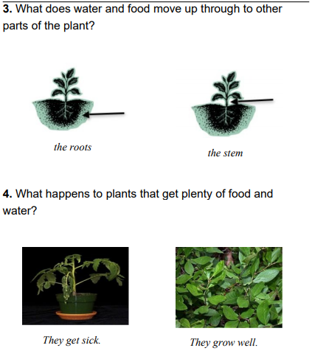
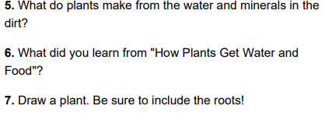

Day 5: A Frog’s Life Cycle from ReadWorks
