KR/Kindergarten | ELA-Week 4
Unit Focus
- Students will orally retell familiar stories, giving characters, setting and important events in the story.
- Students will write to retell those familiar stories, including all elements stated above.
- Students will orally identify main topic and retell key details of an informational text.
- Students will write to retell key details in informational text.
- Students will decode CVC words and/or use CVC words in above writings.
- Students will read decodable texts.
- Students will read sentences for fluency.
- Practice reading and spelling of sight words
Day 1
Chicken Little from CKLA Open Source.
- Parents read the passage. Have student read along or independently read, depending on ability.
- Have student give an oral and written response to the text.
- Have student retell events from beginning, middle, and end of text.
- Complete a story map by having the student draw a picture including the characters, setting and problem/solution.
- 15 minutes of iReady Reading
Writing Activity: Illustrate and/or write about one or multiple characters in the story. Try to use sight words, correct capitalization, finger space, and correct punctuation.

CVC Word Practice: Build cvc words using magnetic letters on an aluminum pan or tray.
https://www.youtube.com/watch?v=oDVAhDyHZaA&t=74s

Sight Word Practice: Build sight words out of playdoh.
Take a brain break and practice your sight words and move at the same time with Jack Hartmann Popcorn Words! https://www.youtube.com/watch?v=Zh7oa6KOHmc
Day 2
The Seasons of Farming from CKLA Open Source
- Parents read the passage. Have student read along or independently read, depending on ability.
- Have students answer questions in response to the text. The questions are found at the end of the story.
- Have students create a 4 square on paper and label the 4 squares; Fall, Winter, Spring and Summer.
- Have students draw and label a picture in each square showing what kinds of jobs a Farmer can do in each season. Encourage your child to use sound spelling.
- 15 minutes of iReady Reading
Writing Activity: Pretending you are a farmer, illustrate and/or write about the activities you would complete if you had your own farm. Try to use sight words, correct capitalization, finger space, and correct punctuation.

Sight Word Practice: Write sight words on popsicle sticks/small sheets of paper. Write “DYNAMITE” on a couple of sticks and then put them all in a jar. Pull them out one at a time and read the word. If you pull dynamite, then you have to put them all back in!
Take a brain break and practice your sight words with Jack Hartmann’s Sight Word Rap 3 https://www.youtube.com/watch?v=1ebGBO3mBwM
Day 3
Enjoying the Outdoors from ReadWorks
- Parents read the passage. Have student read along or independently read, depending on ability.
- Have students answer questions in response to the text. The questions are found at the end of the story.
- Have students draw and label 3 outdoor activities that they would enjoy from the story.
- 15 minutes of iReady Reading
Writing Activity: Think of your favorite activity during recess. Illustrate and/or write about your favorite recess activity. Try to use sight words, correct capitalization, finger space, and correct punctuation.

CVC Word Practice: Search for cvc words around your house and write them on a sheet of paper.
https://www.youtube.com/watch?v=ii18uH36ySU

Sight Word Practice: Lay words down on the floor. Each step you take, say the sight word! If you have stairs, then put one word on each step and say the word as you climb up!
Take a brain break and practice your sight words with Jack Hartmann’s Sight Words https://www.youtube.com/watch?v=1ebGBO3mBwM
Day 4
Some Trees Give Us Food from ReadWorks
- Parents read the passage. Have student read along or independently read, depending on ability.
- Have students answer the guiding questions in response to the text. The questions are found at the end of the story.
- Have students draw and label a tree that grows food people can eat from the text.
- 15 minutes of iReady Reading
Writing Activity: Choose your favorite food that comes from a tree. Illustrate and/ or write about what it smells, taste, feels, and looks like. Try to use sight words, correct capitalization, finger space, and correct punctuation.

Sight Word Practice: Look for sight words in your favorite story! Write down which words you find. Use different colored crayons to write them down!
Take a brain break and practice your sight words with Jack Hartmann’s Popcorn Words https://www.youtube.com/watch?v=Wwe6fttdyh4
Day 5
The Crows from Reading Vine

- Parents read the passage. Have student read along or independently read, depending on ability.
- Have students answer the guiding questions in response to the text. The questions are found at the end of the story.
- Have students orally retell the story, draw your favorite part of the story. Why is that part of the story your favorite?
- What was the problem in the story? What was the solution?
- 15 minutes of iReady Reading
Writing Activity: Think about the two black crows. Write/illustrate how they are alike/different. Try to use sight words, correct capitalization, finger space, and correct punctuation.

CVC Word Practice: The parent will say a cvc word. The student will sound spell the word.
https://www.youtube.com/watch?v=ZAZ74S0vPqs&t=72s

Sight Word Practice: Write sight words with any of the following items: shaving cream, whipped cream, sand/dirt, chalk, playdoh!
Take a brain break and practice your sight words with Jack Hartmann’s Sight Word Rap #1 https://www.youtube.com/watch?v=3zJJ1S6-rMc
Please note that you are to create activities to support the unit focuses and stories/articles. I provided several ideas and activities in the past three weeks which you can use or create new activities for your students.

Story 1: Chicken Little (CKLA Open Source Version)
One fine morning, Chicken Little went out to the woods. As she walked along, an acorn fell on her head.
Chicken Little was a silly little chicken, and she often made silly mistakes. Chicken Little thought the acorn was a part of the sky!
Chicken Little was so caught by surprise that she worked herself into a tizzy.
“Oh dear me!” she cried. “The sky is falling. I must go and tell the king!”
On her way to see the king, Chicken Little met Henny Penny. “Henny Penny, the sky is falling!” cried Chicken Little.
“How do you know?” asked Henny Penny. “A piece of it fell on my poor head,” said Chicken Little, rubbing her poor little noggin with the memory of it.
“Then let us go and tell the king!” said Henny Penny, who now felt quite worried as well.

So Henny Penny and Chicken Little ran along until they met Goosey Loosey.
“Goosey Loosey, the sky is falling!” cried Henny Penny.
“How do you know?” asked Goosey Loosey.
“A piece of it fell on my poor head,” said Chicken Little.
Goosey Loosey looked at Henny Penny, who nodded in agreement.
“Then let us go and tell the king!” said Goosey Loosey, who could not help but believe her friends.
So Goosey Loosey, Henny Penny, and Chicken Little hurried along until they met Ducky Lucky.
“Ducky Lucky, the sky is falling!” cried Goosey Loosey.
“How do you know?” asked Ducky Lucky.
“A piece of it fell on my poor head,” said Chicken Little. Henny Penny and Goosey Loosey stood nodding their heads, wide-eyed, next to Chicken Little.
Ducky Lucky looked at her three friends and became worried because they were so worried. “Then let us go and tell the king!” said Ducky Lucky.
So Ducky Lucky, Goosey Loosey, Henny Penny, and Chicken Little ran along until they met Turkey Lurkey, who was certainly the biggest of the birds.
“Turkey Lurkey, the sky is falling!” cried Ducky Lucky.
“How do you know?” asked Turkey Lurkey.
“A piece of it fell on my poor head,” said Chicken Little. Henny Penny, Goosey Loosey, and Ducky Lucky stood behind Chicken Little, flapping their wings with worry.
“Then let us go and tell the king!” said Turkey Lurkey, for who was he to disagree with four scared friends?
So the five feathered friends ran along until they met Foxy Loxy.
 Show image 1A-4: Goosey Loosey, Henny Penny, Ducky Lucky, Turkey Lurkey, and Chicken Little meeting Foxy Loxy “Foxy Loxy, the sky is falling!” cried Turkey Lurkey.
“Oh, is that so?” said sly Foxy Loxy, who knew better, but pretended to believe the five trembling birds.
“If the sky is falling, you’d better keep safe in my den, and I will go and tell the king for you.”
So Chicken Little, Henny Penny, Goosey Loosey, Ducky Lucky, and Turkey Lurkey followed Foxy Loxy into his den. The dust in the den made Chicken Little sneeze. Achoo! The force of the sneeze made Chicken Little come back to her senses.
“Wait!” cried Chicken Little. “Birds are supposed to stay away from foxes!”
Henny Penny, Goosey Loosey, Ducky Lucky, and Turkey Lurkey looked at each other in amazement. “You are right!” they cried.
And so the five feathered friends ran out of the cave and never went back there again. And from that day on, they thought very carefully before believing that the sky was falling again.
Guiding Questions:
- What is the title of the story?
- Who are the characters in the story?
- Did a piece of the sky really fall on Chicken Little’s head? How do you know?
- Which animals believed Chicken Little when she said the sky was falling?
- Which animal does not believe her?
- Why do the birds come out of the fox’s den?
- If you were Chicken Little, and you thought the sky was falling, what would you have done?
Pictures to use with the story
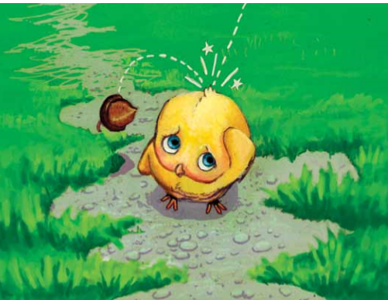
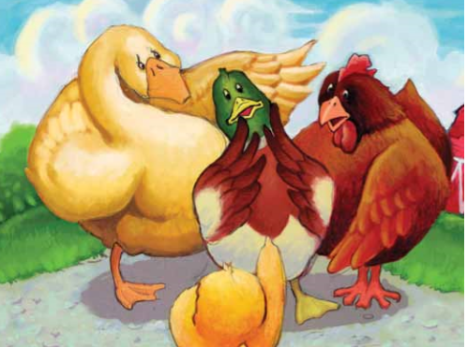

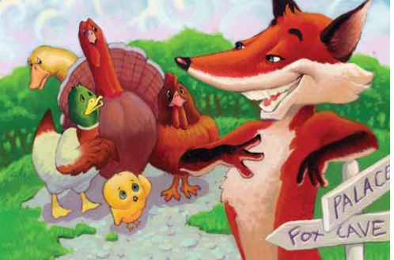

Story 2: The Seasons of Farming (CKLA Open Source)
There are four seasons in a year. Spring always follows winter. Summer always follows spring. And fall, or autumn, always follows summer. After autumn comes winter, and the cycle begins anew.
A farmer’s work—the jobs he or she does each day—changes from season to season. He or she does certain jobs in the spring, summer, fall, and winter. When we talk about the way in which a farmer’s jobs change according to the seasons, it makes sense to begin with spring.
Springtime is when plants awaken from the long winter. New buds, leaves, and blossoms appear on trees, and wildflowers bloom in the fields. Springtime also marks the beginning of the crop cycle, when seeds are planted and new crops begin to grow.
A farmer cannot plant if he does not prepare the ground first. Typically, this is done with a plow. This plow has long sharp teeth that dig into the earth, shredding the dirt and plants to make room for new seeds.
In order to prepare, or cultivate, the soil, the farmer adds a little fertilizer, just to make sure that there are plenty of nutrients for his plants. Some fertilizers are made from chemicals and others are made from animal manure, or animal waste.
To plant large crops, most farmers use tractor-driven seed spreaders like this one. It drops the seeds into the rows that the farmer has already plowed and fertilized. As it passes, dropping seeds evenly in the rows, the seed spreader brushes a layer of soil over the seeds.
After planting, the farmer watches the weather and hopes for rain. The seeds need water in order to sprout into seedlings. In many places, spring is also a rainy season. Few things make a farmer happier than the sight of dark rain clouds overhead.
Eventually, the brown field will turn green as seedlings emerge from the soil. Once they have sprouted, the new plants will continue to need water. By the time spring makes way for summer, these corn plants will be about knee-high. Hopefully, they will continue to grow taller and taller throughout the hot summer.
Sometimes, problems arise and the plants do not grow as expected. Crops fail, or die, sometimes, no matter how hard a farmer works and no matter how much he knows about farming. Drought is one of the farmer’s worst enemies. A drought occurs when it does not rain for a very long time. Droughts occur most frequently during the summertime. The crop in this picture is supposed to be tall and green. Instead, because of a drought, the crop is brown and wilted.
If he has a good source of water nearby, the farmer can irrigate his crops. However, a long drought can cause wells and rivers to dry up. Irrigation can work well but only if there is adequate rainfall.
Unfortunately, rain isn’t the only thing a farmer needs to worry about. Pests can ruin a crop, as well, especially in the summer. This is a locust, which is a type of grasshopper. Locusts are famous for destroying crops by eating them. Various types of worms, beetles, flies, and other insects can also eat a farmer’s crops.
Fortunately, farmers have ways of protecting their crops. Sometimes, farmers spray pesticides—or chemicals that repel bugs and insects—in order to ensure that the crop will survive and yield plenty of fruits or vegetables. A farmer can apply pesticides using the same equipment he uses to fertilize his crops. For very large crops, or fragile crops that could be damaged by tractor wheels, the farmer can hire a crop duster. A crop duster is a type of airplane. The pilot swoops down out of the sky, opens his hatch, and releases the pesticides over the crops. The crop duster can spread pesticides over a large area, and the farmer doesn’t have to worry about trampling his crops with tractor tires.
On some farms, harvest time is the hardest time. Most crops need to be harvested at just the right time or they will spoil. Harvest time is different for different crops and runs typically from early summer through the fall season. Some crops, like certain grapes, must be harvested by hand so they are not damaged. During harvest time, farmers need all the help they can get. They often hire part-time helpers or farmhands to help bring in the harvest as quickly as possible.
Actually, not all farmers need to plant new crops every winter. Farmers that own orchards, or fruit-tree farms, such as apples and peaches, only have to plant each tree one time. That may sound easier, but it also requires a lot of hard work and patience, as every orchard farmer knows. Once these apple trees are planted, the orchard owner must wait several years before they are able to produce big, red, juicy apples. After the trees are fully grown, they will follow the usual crop cycle—producing new leaves and flowers in the spring and young fruits in the summer. The apples grow all summer long until fall, when it is apple-picking time.
After harvest time, the farmer is finally able to take a rest. You might think that winter would be the easiest season for a farmer and compared to other seasons it probably is. However, winter is the only time the farmer has to fix tools and machinery that has worn out or broken during the rest of the year. It is also time to plan for the next planting season—to buy seeds and test the soil to decide how much fertilizer he will need next year. No matter the season, there is always work to be done on the farm.

Guiding questions:
- What are the four seasons of the year?
- What can farmers do to protect their crops from drought?
- What can farmers do to protect their crops from pests?
- Pretend you are a farmer, what kind of jobs can you do in the spring?
- Pretend you are a farmer, what kind of jobs can you do in the summer?
- Pretend you are a farmer, what kind of jobs can you do in the fall?
- Pretend you are a farmer, what kind of jobs can you do in the winter?
- Which season of the year do you think is most important on the farm? Why?
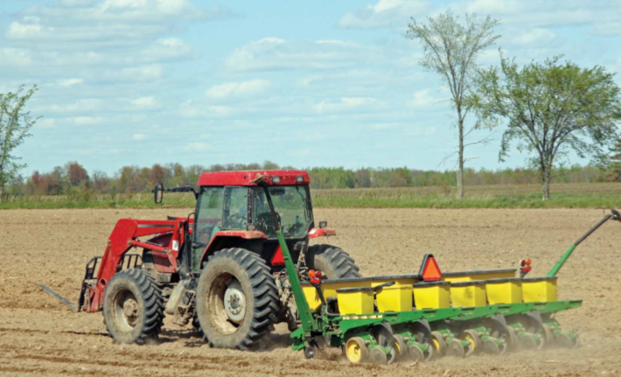
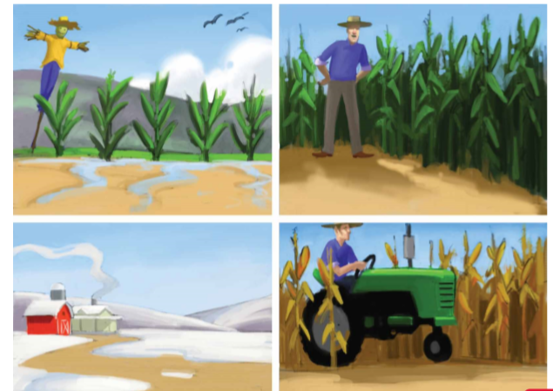
Pictures to use with the story.

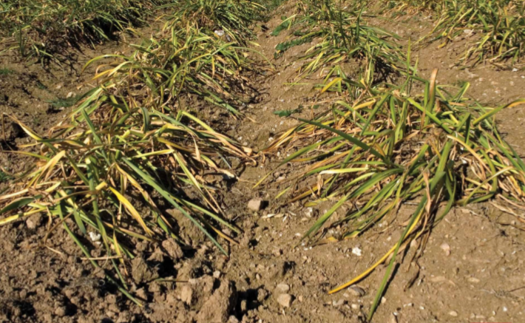
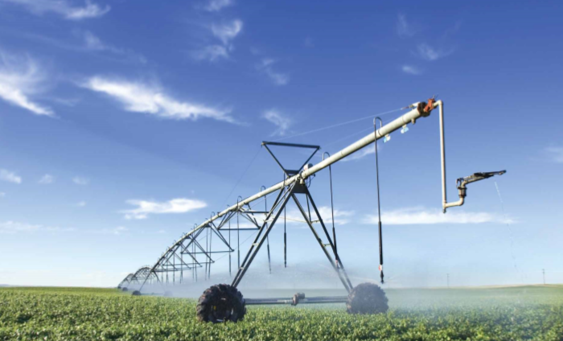
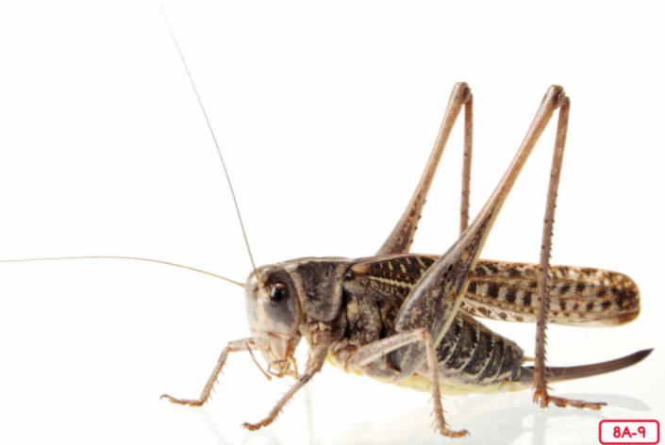

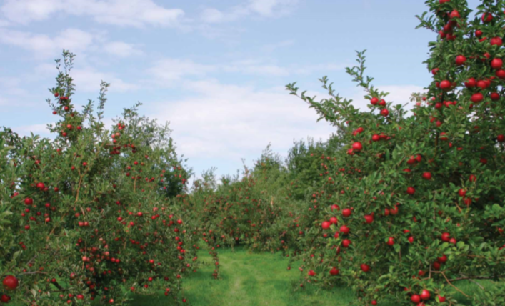

Story 3: Enjoying the Outdoors (ReadWorks)
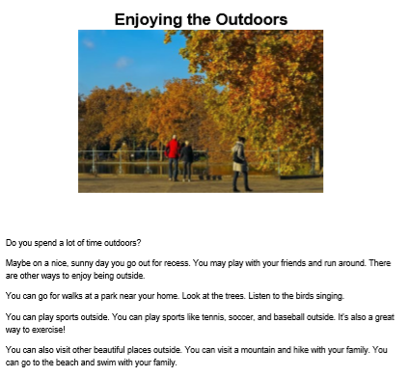
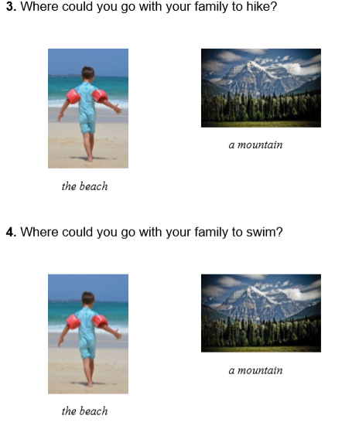
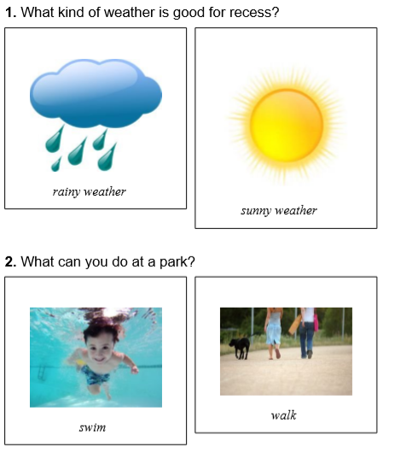

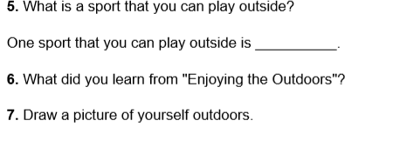
Story 4: Some Trees Give Us Food (ReadWorks)
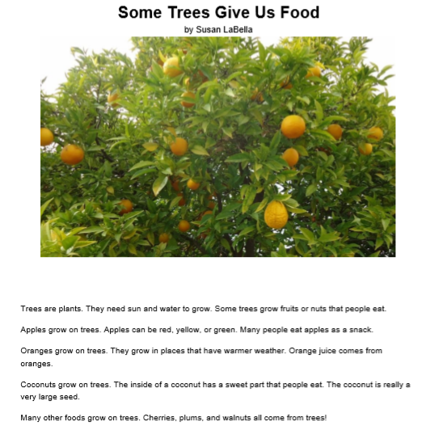
Questions below
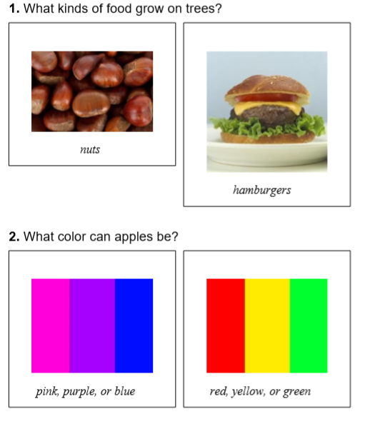
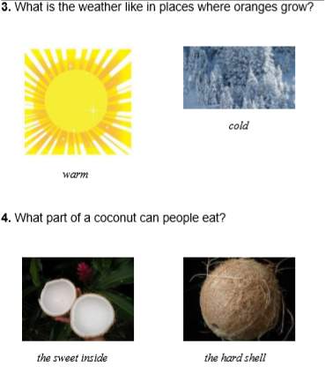

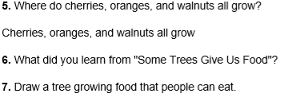

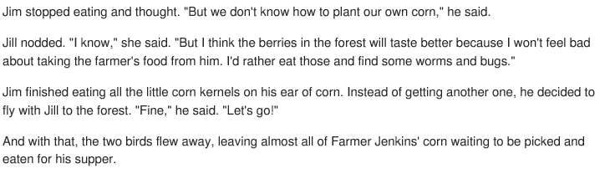
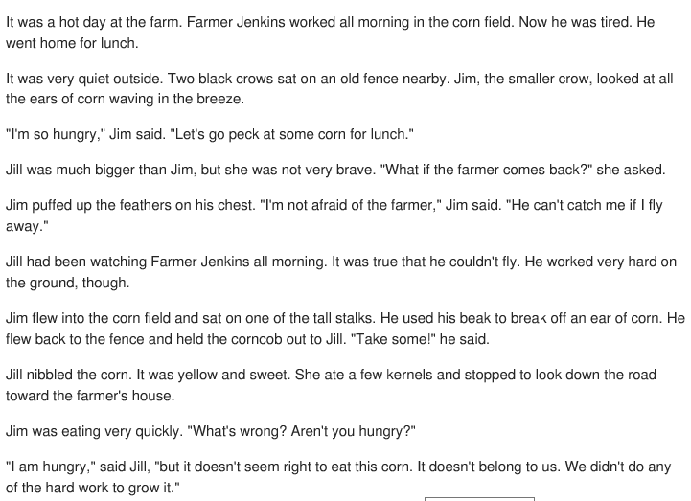
Story 5: The Crows (Reading Vine)
Guiding Questions
- How are Jim and Jill different?
- Why doesn’t Jill eat the corn that Jim brings her?
- What does Jill end up eating for lunch?
- Do you think it is right or wrong for the crows to eat the farmer’s corn?

